[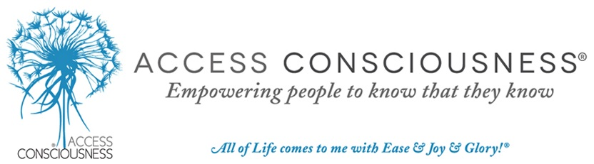](https://accessllc.infusionsoft.com/go/accesshomepage/JMayo)

For anything to not be working for you, you have to be functioning from unconsciousness or *anti-consciousness*. Whenever you cut off your awareness, you are not present. This can make life difficult to navigate. What areas of your life would you like to change?: Your **health**, **career**, **finances**, **relationships**? Regardless, the possibilities are endless!

**ACCESS BARS, A LIFE CHANGING HOLISTIC TECHNIQUE**

There are 32 points/bars of energy on your head known as the Access Bars that connect to different aspects of your life.  These aspects/areas include **money**, aging, **body**, sexuality, joy, sadness, **healing**, creativity, awareness and control, plus many more.

They store the electromagnetic component of all the thoughts, ideas, attitudes, decisions and beliefs that you have ever had about anything. When gently touched they start to clear all of the limitations you have about this different areas of your life and body. Think: What would it be like to have more **freedom** in all these areas?

Touch one Bar and you begin to clear away the energy locked up in that area or aspect of your life just by touching it. Add in touching another Bar and you not only get the “issues” from the first Bar, you also begin clearing the “issues” stored in that second Bar. As well you clear all the points of view about those two Bars in relation to each other, allowing for exponential change.

Each thought, feeling, emotion, idea, attitude, decision or belief that you have fixed in place **solidifies the energy** and **limits your capacity** to be generative in that area and to have something different show up in your life with ease.

During a BARS SESSION, **The Bars** are gently touched, which **discharges** the stored**polarity**. This creates**space**for new**possibilities** to show up in your body and your life. Just five minutes can erase 5,000 to 10,000 years of stored points of view.

So, what is the value of erasing this bank of data you have stored all this lifetime, and every lifetime? Each thought, idea, attitude, decision or belief that you have fixed in place solidifies the energy and limits your capacity to change anything in that area. You change the energy, you change how that part of your life shows up. What is the most simple and easy way to change energy? Get your Bars touched! When you do, something different can show up in your life with ease.

This is an incredibly **nurturing and relaxing** process, undoing limitation in all aspects of your life without any effort. When you are functioning from preconceived points of view about what is possible in life, what is not possible in life, and have it rigidly defined of how the world works, you cannot be aware of anything that does not match that.

**Benefits of having your bars run:**

* Neutralize and discharge the energy holding of negative and limiting beliefs in place in their neural connections
* Release stress and tension
* Turn off endless mind chatter
* Turn on inner peace and calmness
* Allow better focus and concentration
* Similar to emptying the recycle bin on your computer
* Lower brainwaves to allow behavioural patterns and addictions to be addressed
* Increase energy levels
* Heal emotional issues and trauma
* Release trapped emotions
* Minimize pain
* Improve body image issues
* Aid successful weight management
* Accelerate healing
* Improve your sleep
* Make your negative issues disappear
* Immunize yourself against negative influences
* Allow more joy, happiness and abundance
* and a lot more...

**SO…..ARE YOU WILLING TO RECEIVE?**

Having your Bars run allows you to **begin to receive**. Learning to receive can be one of the hardest things for many of us to learn. Most of us know how to do and how to give, but not how to receive. You have to be willing to receive if you are going to **have the life you truly desire**.

Some of the other benefits many experience from this gentle touch **holistic therapy** **technique** include **improved sleep**, **mental clarity**, **calmness** and **inner peace** as well as reduced stress and decreased depression, frustration, sadness and anxiety.

<http://www.accessconsciousness.com/>

If you want your Bars Run, do not hesitate to contact me for a session or additional info:

**Therapist Mrs. Laura Méndez**

Bars Facilitator - QHHT Hypnotherapist/Past Life Regression (www.dolorescannon.com)

LEBANON: Mobile +961 904742

U.A.E.: Mobile +971 507165505

URUGUAY: Tel +598 23073720

Email: lb.mendezqhht@gmail.com or [lb.mendez@yahoo.com](mailto:lb.mendez@yahoo.com)